**IST471**

**Classroom Assignment 6 (30 points)**

Theme: Beef Up Analytic Reports with Summary Lines

**NOTE: This is an individual assignment**

**Use appropriate SQL formatting commands, along with necessary queries, to produce the following desired reports:**

**Report 1**

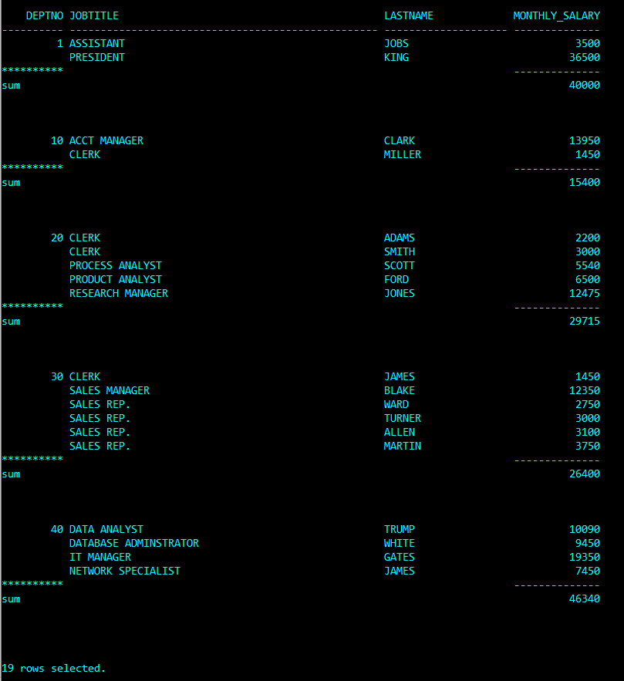

BREAK ON deptno SKIP 1

COMPUTE SUM OF monthly_salary ON jobtitle

SELECT deptno, jobtitle, lastname, monthly_salary

FROM emp

ORDER BY deptno, jobtitle, monthly_salary;

**Report 2**

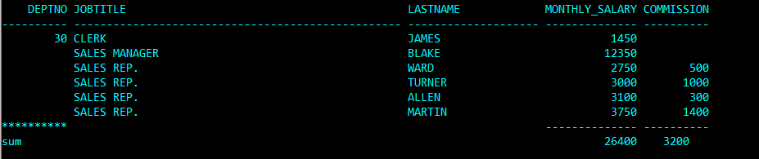

BREAK ON deptno SKIP 1

COMPUTE SUM OF monthly_salary commission ON deptno

SELECT deptno, jobtitle, lastname, monthly_salary, commission

FROM emp

WHERE deptno = 30

ORDER BY deptno, jobtitle, monthly_salary;

**Report 3**

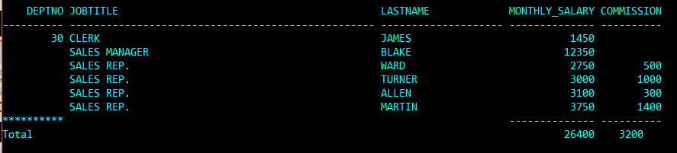

BREAK deptno SKIP 1

COMPUTE SUM LABEL Total OF monthly_salary commission ON deptno

SELECT deptno, jobtitle, lastname, monthly_salary, commission

FROM emp

WHERE deptno = 30

ORDER BY deptno, jobtitle, monthly_salary;

**Report 4**

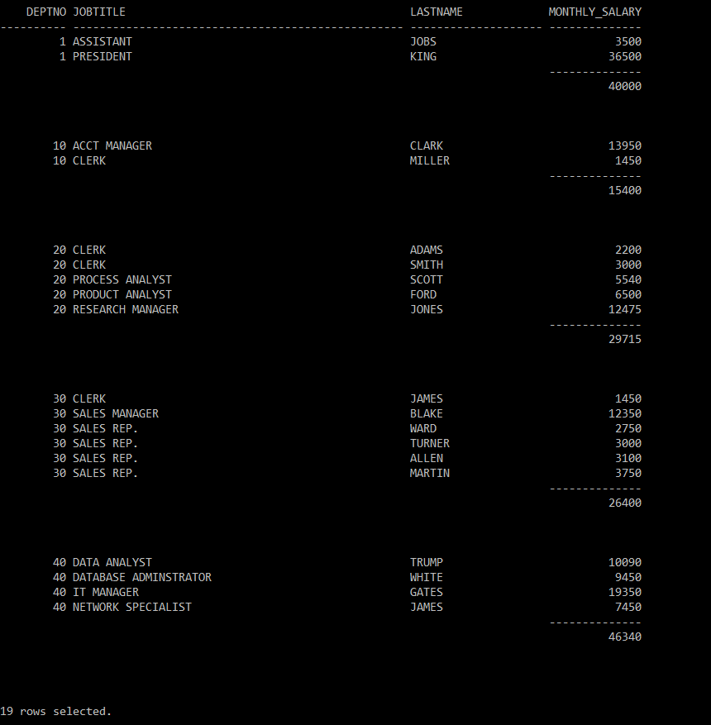

COLUMN DUMMY NOPRINT

BREAK ON DUMMY SKIP 1

COMPUTE SUM OF monthly_salary ON DUMMY

SELECT deptno DUMMY, deptno, jobtitle, lastname, monthly_salary

FROM emp

ORDER BY deptno, jobtitle, monthly_salary;

**Report 5**

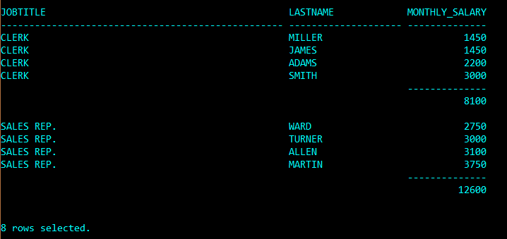

COLUMN DUMMY NOPRINT

BREAK ON DUMMY SKIP 1

COMPUTE SUM OF monthly_salary ON DUMMY

SELECT jobtitle DUMMY, jobtitle, lastname, monthly_salary

FROM emp

WHERE jobtitle IN (‘CLERK’, ‘SALES REP.’)

ORDER BY jobtitle, monthly_salary;

**Report 6**

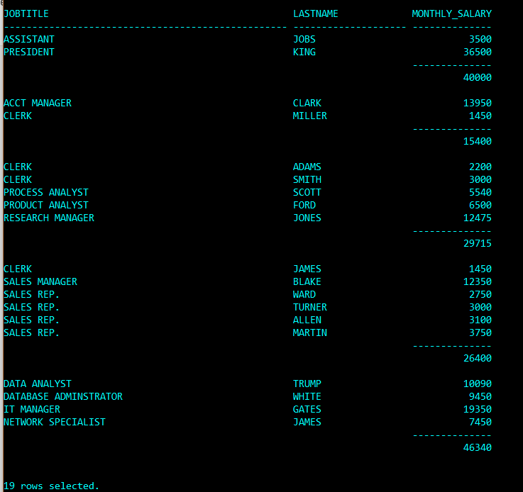

COLUMN deptno NOPRINT

BREAK deptno SKIP 1

COMPUTE SUM OF monthly_salary ON deptno

SELECT deptno, jobtitle, lastname, monthly_salary

FROM emp

ORDER BY deptno, jobtitle, monthly_salary;

**Report 7**

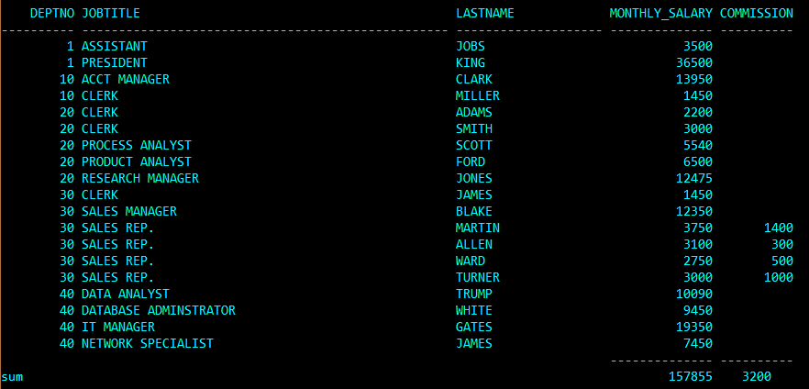

BREAK ON REPORT

COMPUTE SUM OF monthly_salary commission on REPORT

SELECT deptno, jobtitle, lastname, monthly_salary, commission

FROM emp

ORDER BY deptno, jobtitle;

**Report 8**

A screenshot of a social media post with text and a black background

Description generated with high confidence

COLUMN DUMMY NOPRINT

COMPUTE SUM OF monthly_salary ON DUMMY

BREAK ON DUMMY

SELECT NULL DUMMY, deptno, jobtitle, lastname, monthly_salary, commission

FROM emp

ORDER BY deptno, jobtitle;

**Report 9**

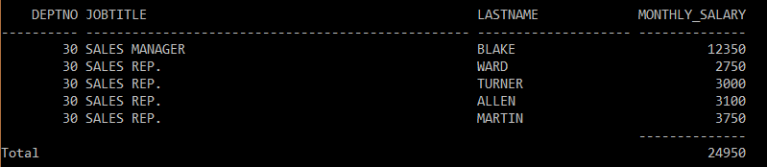

BREAK ON REPORT

COMPUTE SUM LABEL Total OF monthly_salary ON REPORT

SELECT deptno, jobtitle, lastname, monthly_salary

FROM emp

WHERE jobtitle LIKE 'SALES%'

ORDER BY deptno, jobtitle, monthly_salary;

**Report 10**

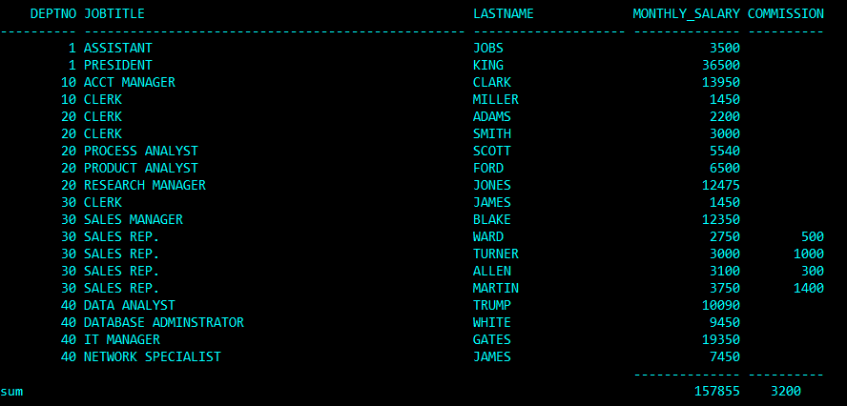

BREAK ON REPORT

COMPUTE SUM OF monthly_salary commission ON REPORT

SELECT deptno, jobtitle, lastname, monthly_salary, commission

FROM emp

ORDER BY deptno, jobtitle, monthly_salary;

**Report 11**

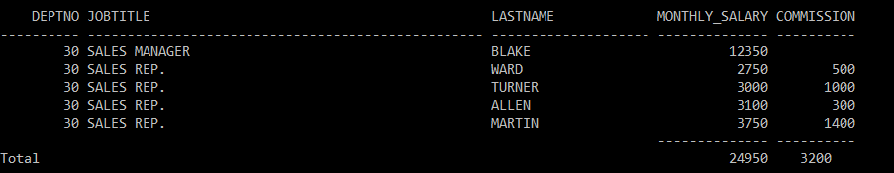

BREAK ON REPORT

COMPUTE SUM LABEL Total OF monthly_salary ON REPORT

SELECT deptno, jobtitle, lastname, monthly_salary, commission

FROM emp

WHERE jobtitle LIKE 'SALES%'

ORDER BY deptno, jobtitle, monthly_salary;

**Report 12**

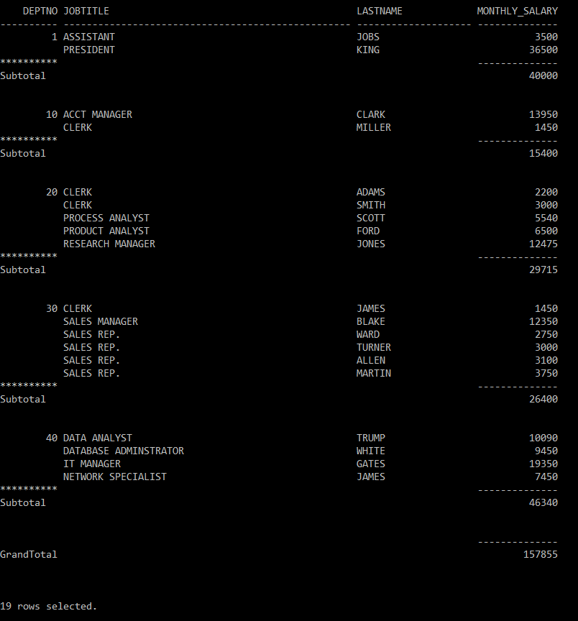

BREAK ON deptno SKIP 1 ON REPORT

COMPUTE SUM LABEL Subtotal OF monthly_salary ON deptno

COMPUTE SUM LABEL GrandTotal OF monthly_salary ON REPORT

SELECT deptno, jobtitle, lastname, monthly_salary

FROM emp

ORDER BY deptno, jobtitle, monthly_salary;

**Report 13**

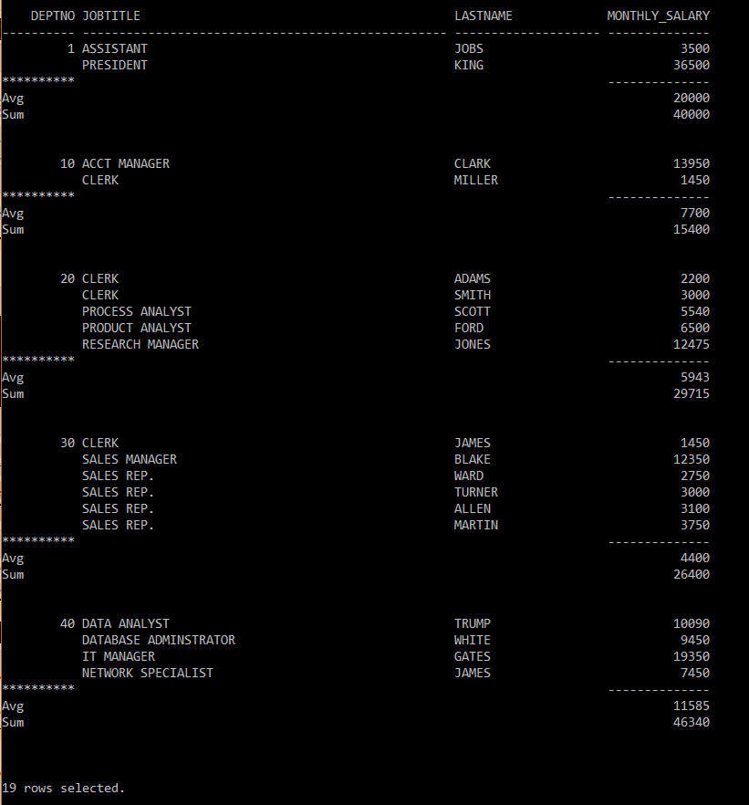

BREAK ON deptno SKIP 2

COMPUTE AVG LABEL, AVERAGE Avg SUM LABEL Total Sum OF monthly_salary ON deptno

SELECT deptno, jobtitle, lastname, monthly_salary

FROM emp

ORDER BY deptno, jobtitle, monthly_salary;